Machine Learning 1

Sample Questions
  - WS18/19

Name:

Subject of study:

Tutorial you attended:

Alexander Lenz / Kashef Karim
Tristan Scheidemann

Points:

Q.1 | Q.2 | Q.3 | Q.4 | Q.5 | Q.6 | Q.7 | Q.8 | Q.9
 |  |  |  |  |  |  |  |  | 100

Q.1 (10 points)
Please answer each of these questions briefly in full sentences. Each correctly answered question adds 2 points to the score. Wrong answers do not subtract points.
What are the differences between the frequentist interpretation of probability and the Bayesian point of view.

For two events $A,B$, write down Bayes’ theorem $P\left(A|B\right)=…$ and mark which terms are the “prior, posterior, likelihood and evidence”.

Explain the role of the prior in our inferences.

Imagine you have $n$ samples and a parameter $θ$. You now receive $m$ additional datapoints. Explain the role of “Bayesian updating” in context of the new posterior $p\left(θ|X_{new},X_{old}\right)∝…$.

Is the likelihood $L\left(θ\right)$ a probability?

Q.2 (10 points)
We are throwing $n$ independent coins with probability $θ=p$. We are interested in finding $θ$.

Q.2.1 (5 points)
Write down the likelihood $L\left(θ\right)$ of this experiment.

Q.2.2 (5 points)
Derive the maximum likelihood solution of $L\left(θ\right)$.
Hint: $θ_{MAX}=\frac{k}{n}, where k=\#heads$

Q.3 (15 points)
We have $n$ samples $\left(t_{i},x_{i}\right)$ that we would like to predict using linear regression.

Q.2.1 (5 points)
We start with the maximum likelihood solution of the $l_{2}$ regularized problem. Derive the maximum likelihood solution of
$${\left(t-Φw\right)}^{T}τ_{ϵ}I\left(t-Φw\right)+\frac{λ}{2}w^{T}w, λ∈R^{+}$$
Some matrix derivative rules:
$$\frac{∂x^{T}a}{∂x}=\frac{∂a^{T}x}{∂x}=a$$ | $$\frac{∂x^{T}Bx}{∂x}=\left(B+B^{T}\right)x$$

Q.2.2 (10 points)
Let the likelihood be $p\left(t|X\right)=N\left(t;Φw,τ_{ϵ}^{-1}I\right)$ and the prior be $p\left(w\right)=N\left(w;0,τ_{0}^{-1}I\right)$.
Derive the posterior $p\left(w|X\right)$. Compare your result with Q.2.1. and explain the similarities (especially with regard to the mean $μ_{N}$ of the posterior).
Hint: Completing the square of $p\left(t|X\right)p\left(w\right)$ avoids us having to calculate the evidence $p\left(t\right)$.

Q.4 (10 points)
The tasks in this exercise are with respect to Bayesian linear regression.

Q.4.1 (8 points)
Explain the bias-variance decomposition in words.
Why does the following plot behave this way:
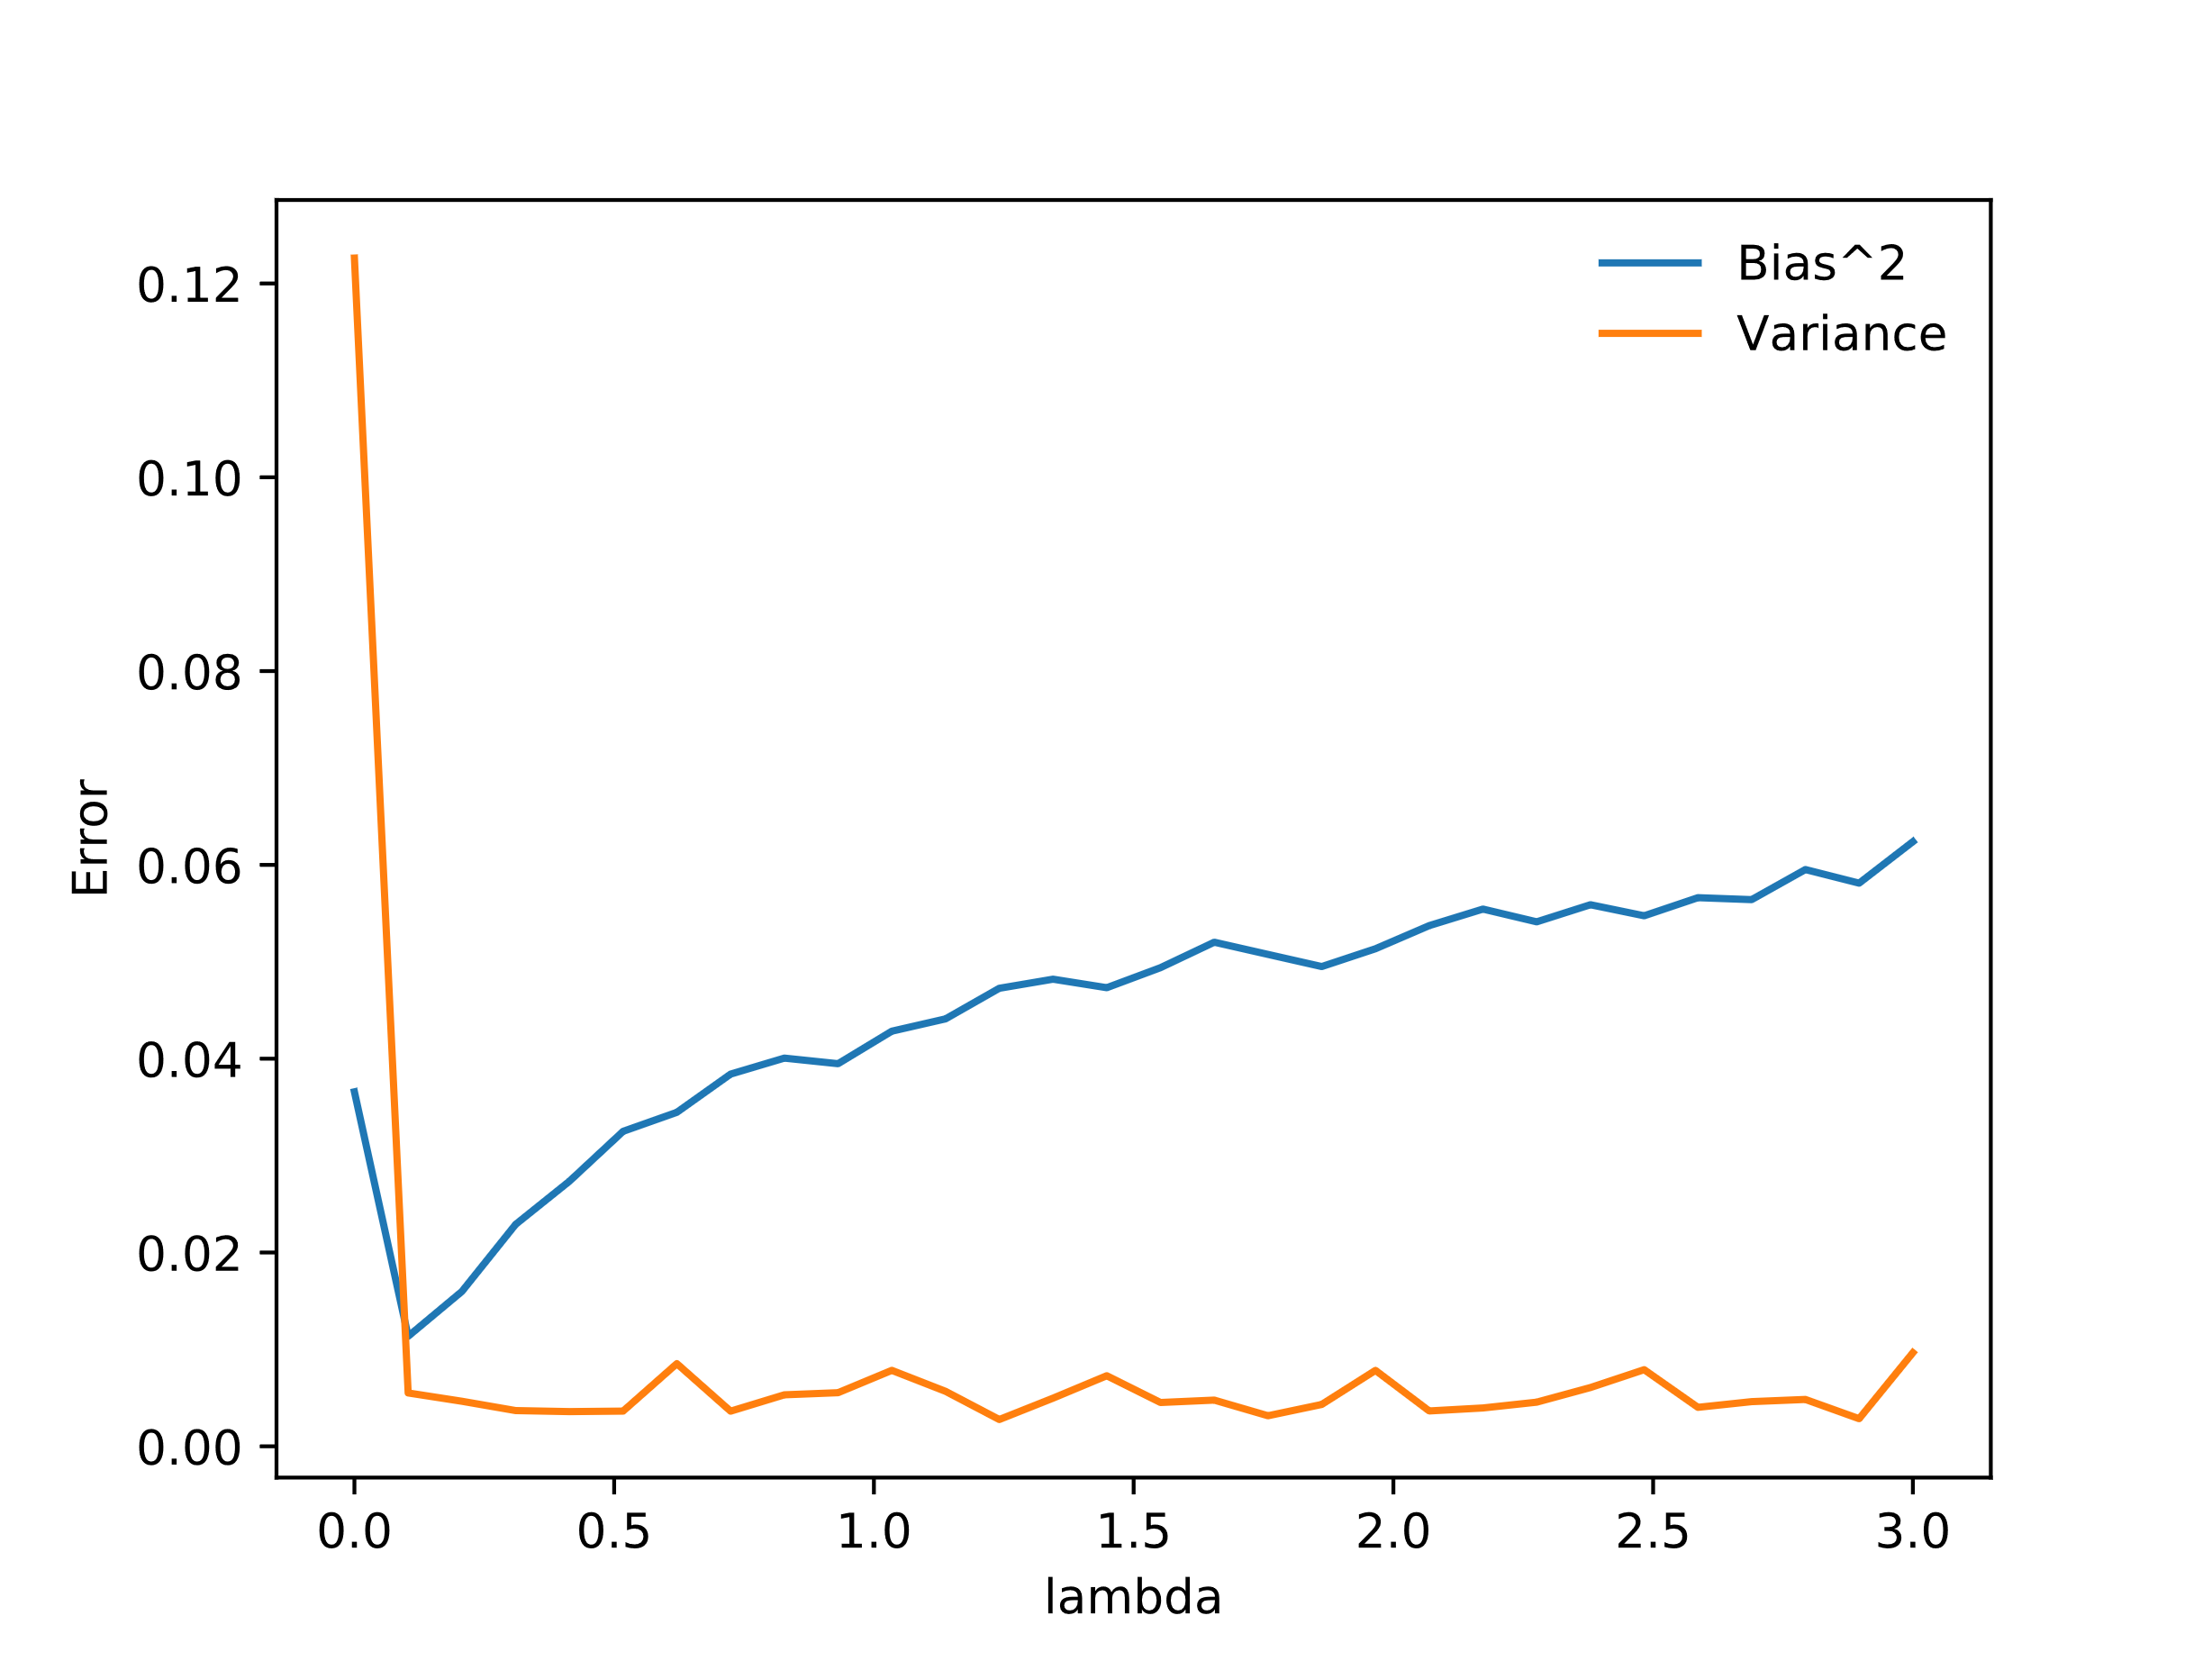

Q.4.2 (2 points)

What are the coefficients $w_{0},w_{1}$ of the polynomial $f\left(x\right)=w_{1}x+w_{0}$ that generated the following plots:
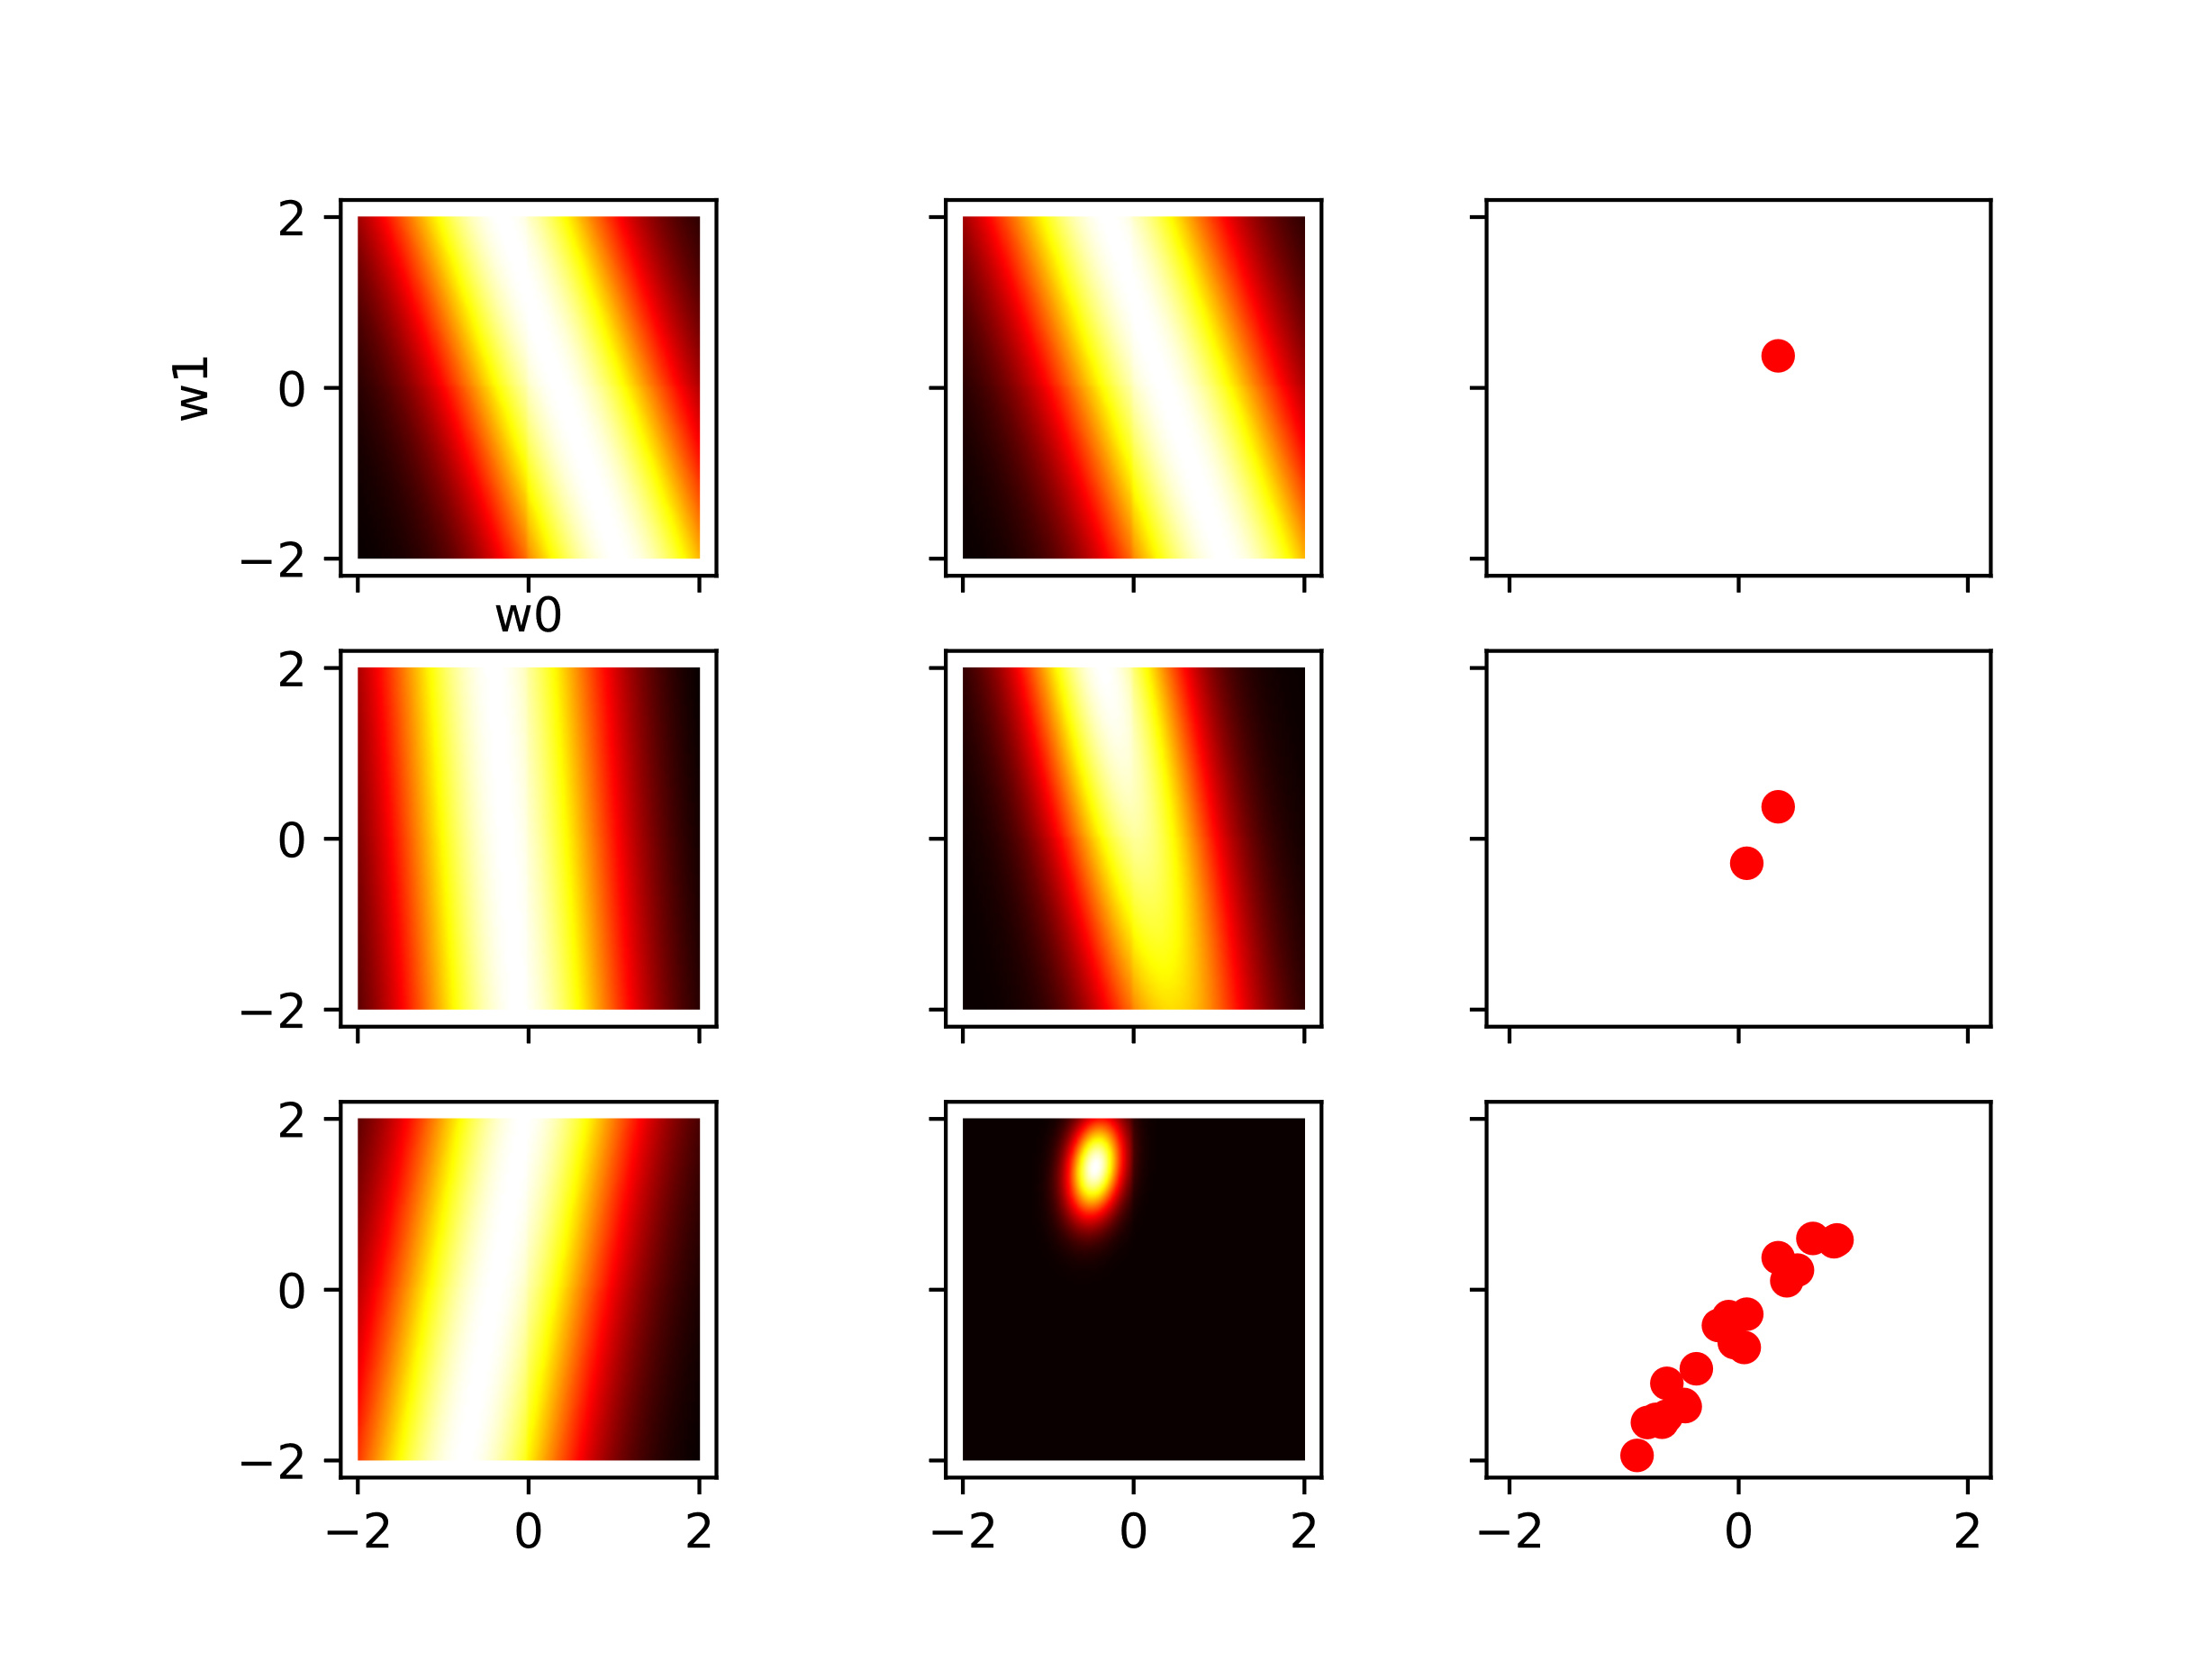

Q.5 (20 points)

Q.5.1 (5 points)
Explain how binary classification using logistic regression works.

Q.5.2 (5 points)
Explain how binary classification using the perceptron works.

Q.5.3 (5 points)
Explain how binary classification using Fisher’s discriminant works

Q.5.4 (5 points)
Explain the “kernel trick”.

Q.6 (20 points)

Given is the following binary data in a classification problem
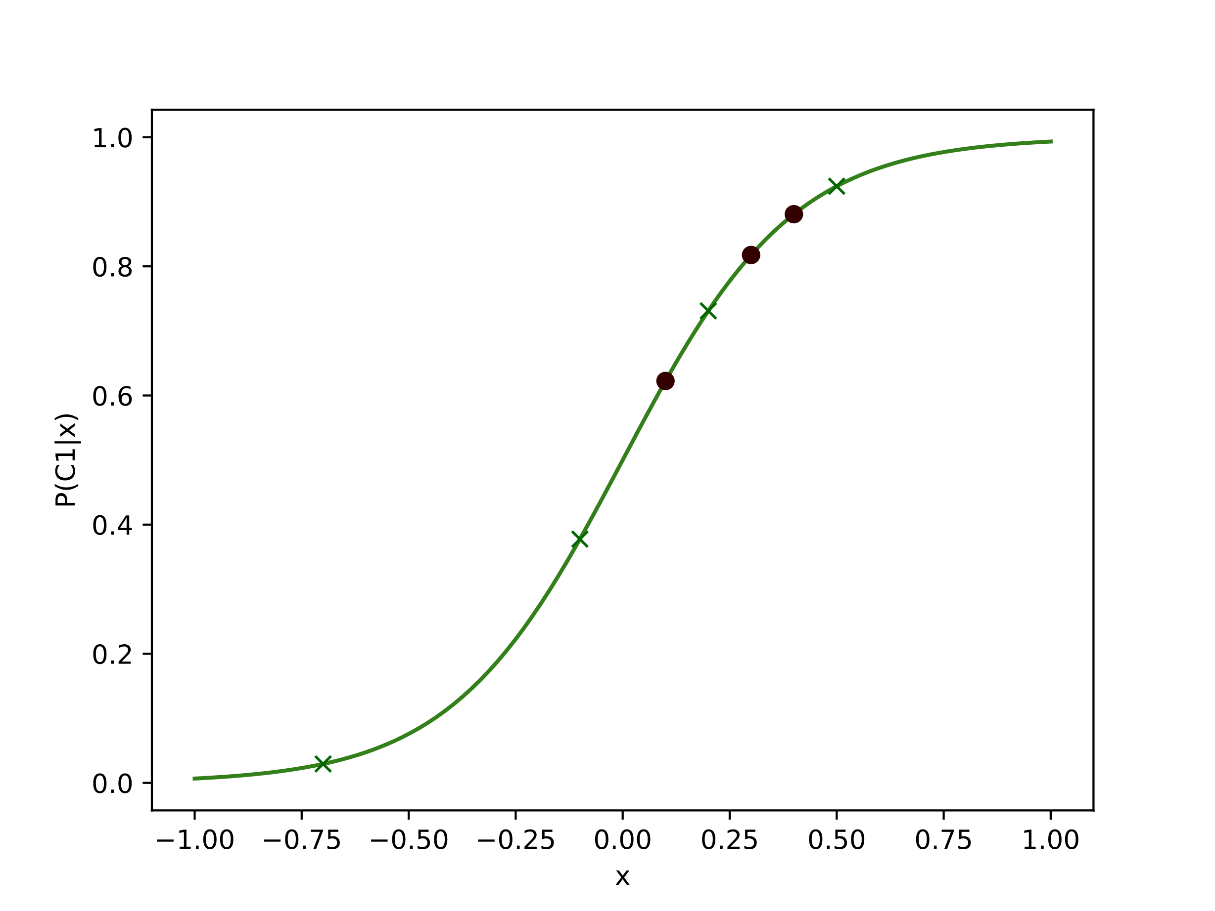
Drawn is $P\left(C_{1}|x\right)=\frac{1}{1+e^{-5x}}$. We classify $x$ belonging to $C_{1}$ if it satisfies $P\left(C_{1}|x\right)>θ$.We want to see how the quality of estimates changes when we differ $θ$.
In other words: Sketch the ROC curve.

$Φ=Design Matrix, w=model weights, I=Identity Matrix.$

